Bradley Lowe
Chelsea Thompto
ART 2434
04 November 2026

https://github.com/NotBradBrad/Homework-10/tree/main/Homework%2010/Landscape_2026_11_04_15_20_05

Planning Sketch:

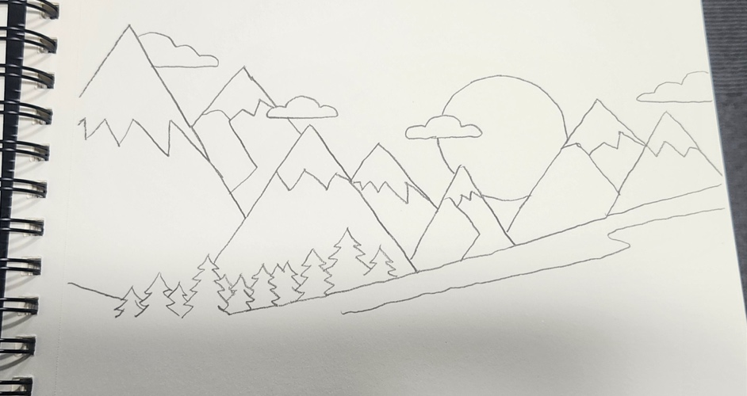

Image when running:



